Social Media Posts

Hashtags you can use:
#UtilitiesAgainstScams
#ScamAware

Twitter, Facebook and LinkedIn

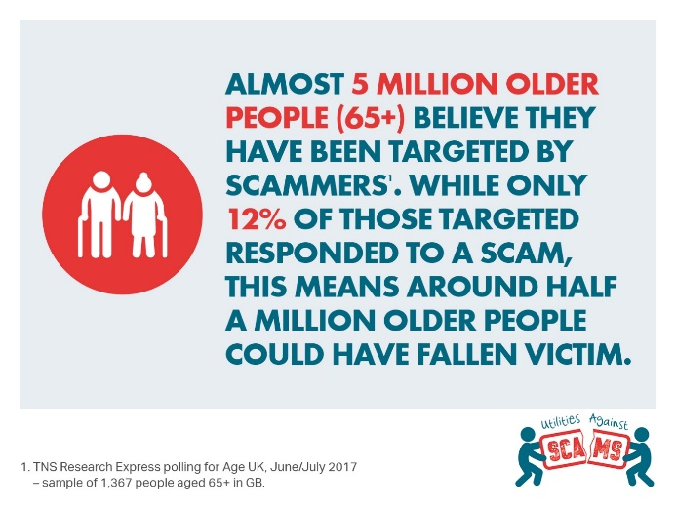

Scams affect the lives of millions of people across the UK daily. We’ve joined forces with other utility companies in the UK energy, water and communications sectors to form #UtilitiesAgainstScams and fight them head-on #ScamAware

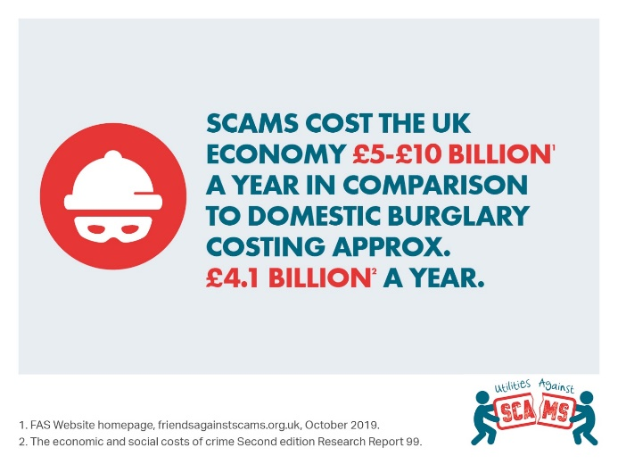

If you have been a victim, don’t be embarrassed about reporting a scam — you could prevent it from happening to others. Please contact Action Fraud on 0300 123 2040 ☎️ #ScamAware

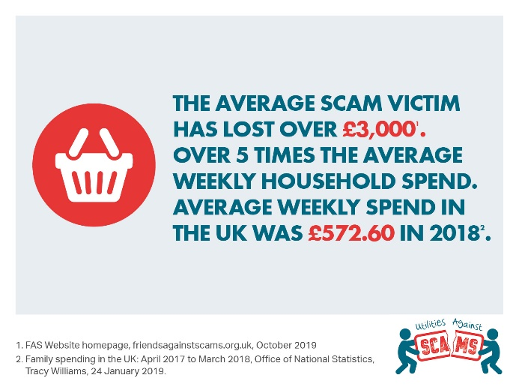

Be Scam Aware
SPOT: If it sounds too good to be true - it probably is
STOP: Take time to stop & think before parting with your details or money – it could keep you safe.
PREVENT: If you spot or think you’ve fallen for a scam, report it to Action Fraud on 0300 123 2040 & get help

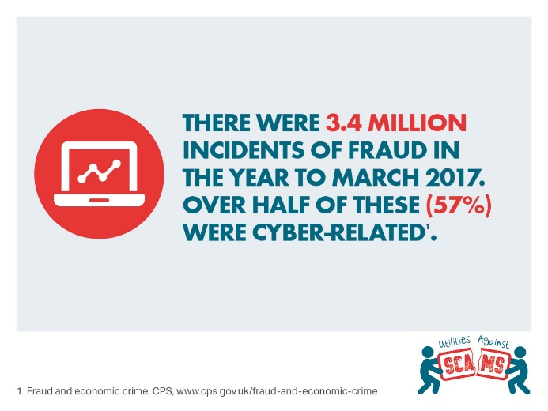

Scams are becoming more commonplace, more sophisticated & harder to spot than ever. We meet & talk to customers daily putting us in an ideal position to spot tell-tale signs & act to prevent scams. We're working with other utilities to raise awareness and prevent scams #ScamAware

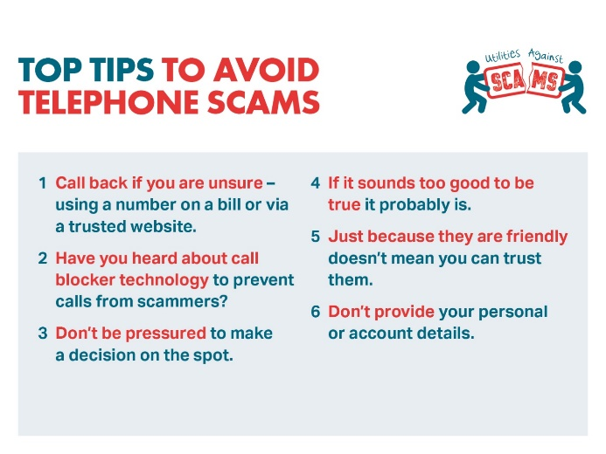

Be #ScamAware! Anyone can be a target and scams affect the lives of millions of people across the UK every day. If you know what to look out for, you’re less likely to be taken in. Criminals may contact you on the phone ☎️ – protect yourself with these top tips #ScamAware

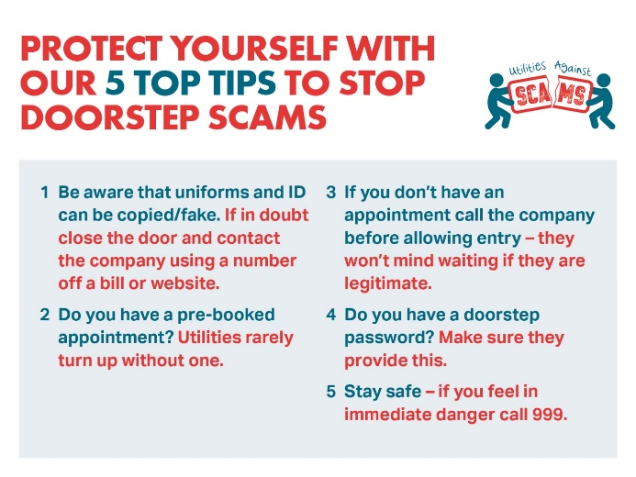

Scams come in a variety of formats, whether it is someone knocking on the door to gain entry, or an email offering a prize in return for money or personal information. Protect yourself from bogus or rogue traders knocking at your door with these top tips #ScamAware

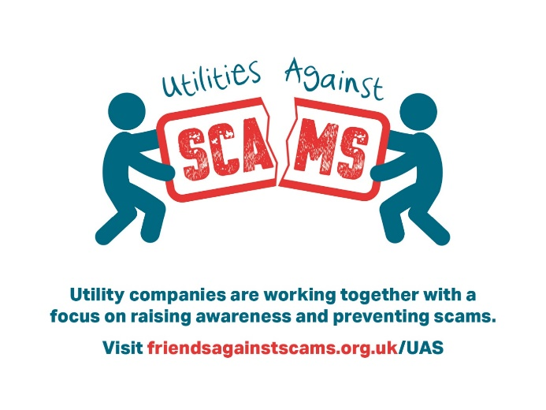

Scams officially cost the UK economy up to £10bn every year. Only 5% are reported, so that figure is likely to be much higher. Working with other utility companies, we are launching #UtilitiesAgainstScams to support our customers and help our employees to spot, stop and prevent a scam #ScamAware

Scams are becoming more commonplace, more sophisticated and harder to spot than ever before. We're in the privileged position of entering customers’ homes for planned and unplanned works, so why we're working with other utility companies to take a stand against scams #ScamAware

