Hashtags –

#UtilitiesAgainstScams
#FriendsAgainstScams
#ScamAware

Twitter and Facebook

Launch day
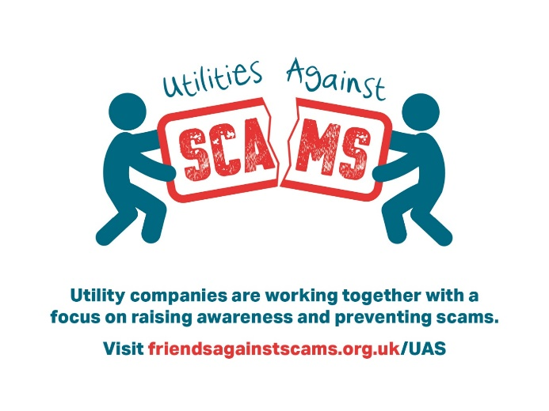

We’re excited to be launching Utilities Against Scams (UAS). UAS provides a way for utility companies to sign up & commit to taking a stand against scams — creating a clear & consistent approach in how we can spot, stop & prevent scams as we interact with the customers we serve.

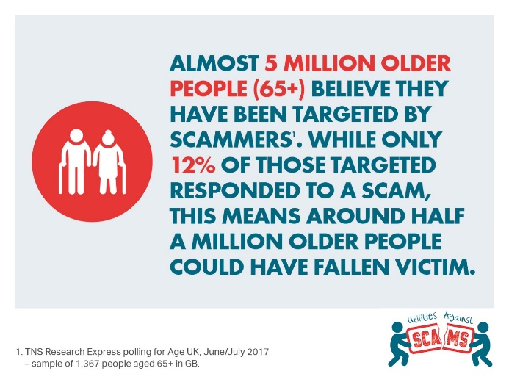

Scams affect the lives of millions of people across the UK daily. We’ve joined forces with other utility companies in the UK energy, water and communications sectors to form Utilities Against Scams and fight them head-on.

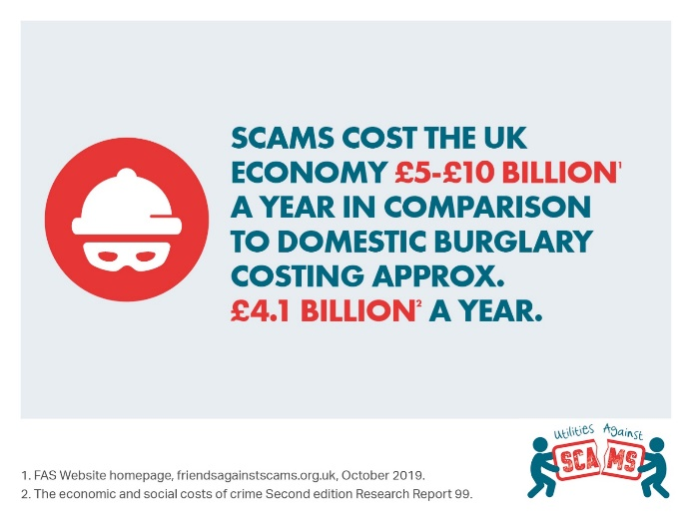
General Posts

If you have been a victim, don’t be embarrassed about reporting a scam — you could prevent it from happening to others. Please contact Action Fraud on 0300 123 2040 ☎️.

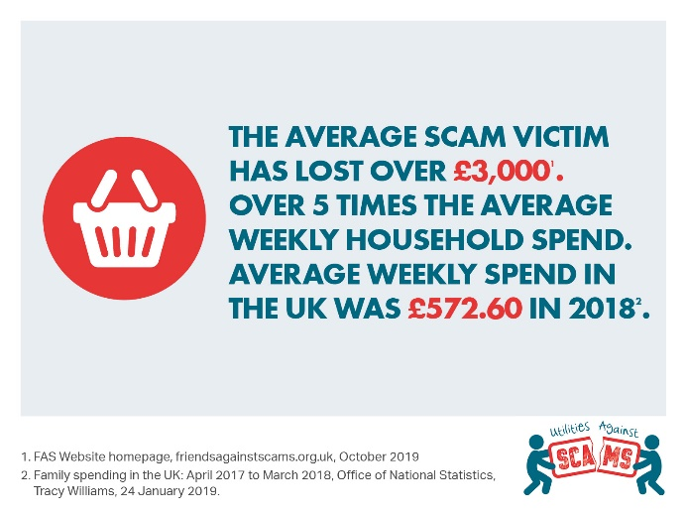

Be Scam Aware
SPOT: If it sounds too good to be true - it probably is
STOP: Take time to stop & think before parting with your details or money – it could keep you safe.
PREVENT: If you spot or think you’ve fallen for a scam, report it to Action Fraud on 0300 123 2040 & get help

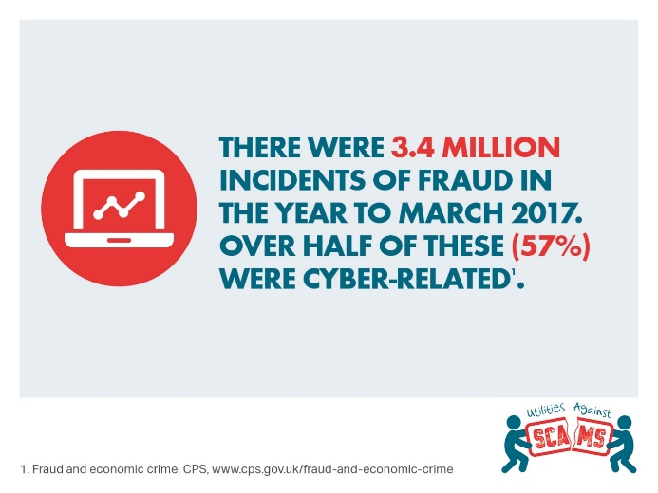

Scams are becoming more commonplace, more sophisticated & harder to spot than ever. We meet & talk to customers daily putting us in an ideal position to spot telltale signs & act to prevent scams. We're working with other utilities to raise awareness and prevent scams.

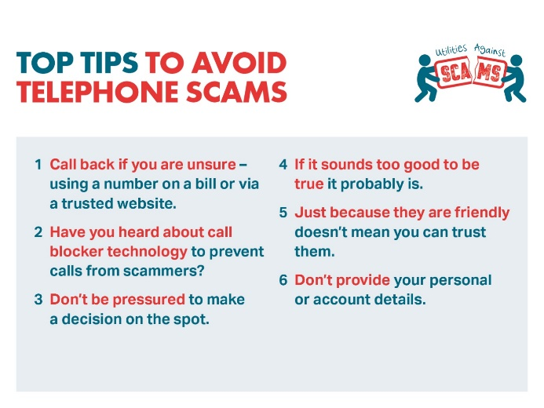

Be Scam Aware! Anyone can be a target and scams affect the lives of millions of people across the UK every day. If you know what to look out for, you’re less likely to be taken in. Scammers may contact you on the phone ☎️ – protect yourself with our top tips

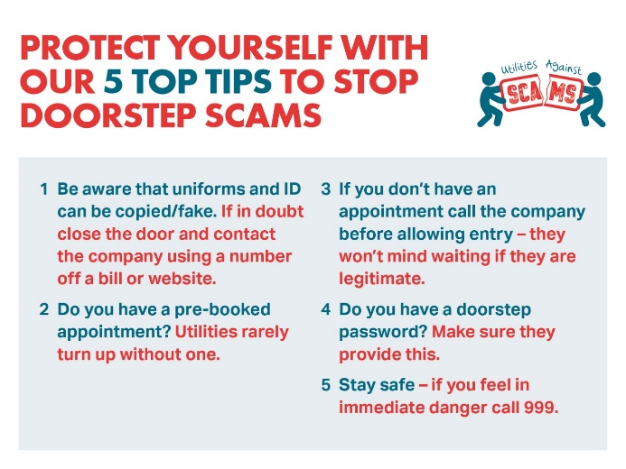

Scams come in a variety of formats, whether it is someone knocking on the door to gain entry, or an email offering a prize in return for money or personal information. Protect yourself from bogus or rogue traders knocking at your door 🚪 with our top tips

Scams officially cost the UK economy up to £10bn every year. Only 5% are reported, so that figure is likely to be much higher. Working with other utility companies, we are launching Utilities Against Scams to support our customers and help our employees to spot, stop and prevent a scam

Scams are becoming more commonplace, more sophisticated and harder to spot than ever before. We're in the privileged position of entering customers’ homes for planned and unplanned works, so why we're working with other utility companies to take a stand against scams

LinkedIn

Launch day

We’re excited to be launching Utilities Against Scams (UAS). UAS provides a way for utility companies to sign up and commit to taking a stand against scams — creating a clear and consistent approach in how we can spot, stop and prevent scams as we interact with the customers we serve.

Backed by National Trading Standards, Utilities Against Scams will pool resources and provide consistent training to thousands of staff who interact daily with customers in their home, on the phone, or digitally. They can then more easily spot warning signs, provide help and report potential scams.

The founding members of UAS – Anglian Water, British Gas, Cadent, Consumer Council for Water, Plusnet, SSE and Yorkshire Water – are also committing to spread the word within the industry, so that the network can expand rapidly and become a major force in fighting scams.

Utilities Against Scams becomes a branch of Friends Against Scams, founded three years ago by National Trading Standards to protect UK consumers from mass marketing fraud. Through this initiative, more than 300,000 people have so far been trained as ‘friends’.

