**UAS web copy**

**B2C**

**Be scam aware**

Scams affect the lives of millions of people across the UK on a daily basis. The National Trading Standards Scams Team estimates that the detriment to UK consumers as a result of these scams is between £5 and 10 billion a year.

**What is a scam?**

A scam is a deception, trick or persuasion done to make a person part with something, usually money. Scams come in many forms including fake emails (phishing), romance scams, winning a fictitious lottery or fake prize, selling of fake music venue tickets, or someone knocking on the doorstep pretending to be a professional tradesperson or utility employee.

Anyone can be a target and scams affect the lives of millions of people across the UK every day.

If you know what to look out for, you’re less likely to be taken in.

SPOT: If it sounds too good to be true – it probably is.

STOP: Take some time to stop and think before parting with your details or money – it could keep you safe.

PREVENT: If you spot a scam or think you’ve fallen for a scam, report it to Action Fraud on 0300 123 2040 and get help.

**We’ve put together some top tips to help you protect yourself and your loved ones against scammers**

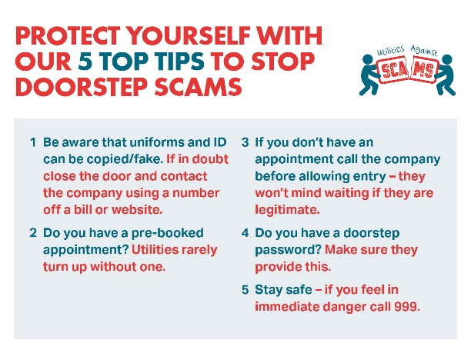 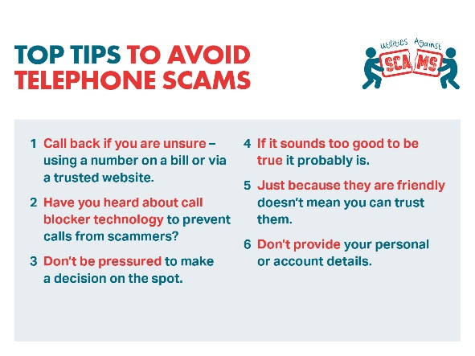

If you have been a victim, don’t be embarrassed about reporting a scam – you could prevent it from happening to others.

Please contact Action Fraud on 0300 123 2040

For more information on scams and how to protect yourself against scammers visit [www.friendsagainstscams.org.uk](http://www.friendsagainstscams.org.uk)

**What is Utilities Against Scams?**

We are working together with other utility companies and National Trading Standards to raise awareness around scams as it is a growing issue affecting people globally. ​

Utility companies interact customers on a daily basis, whether this is face-to-face when carrying out work in a community or in a customer’s home, having a telephone conversation or communicating digitally.

With the digital age, it is becoming easier for criminals to pose as legitimate companies and scam people out of large sums of money. This not only impacts on customers both financially and emotionally, but also creates reputational risk for businesses and the wider industry. ​

We can play a crucial part in spotting signs that a customer could need support and alerting those organisations who can help.