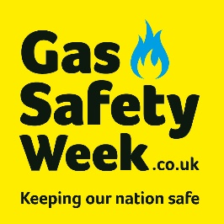
Gas Safety Week 2025: Social media schedule

Be a part of Gas Safety Week by using these suggested social media updates. Just copy and paste the messages below to your social media accounts during Gas Safety Week. You will find the images and a video to use alongside them in the toolkit. Both are available in sizes 1:1 and 9:16.

Monday  Theme - Looking after your home, friends and family. | (MP4) | Gas Safety Week 2025 has arrived! This year is about keeping our family and those around us gas safe. Because we all have a role in creating a gas safe nation, and your role can make all the difference. Find out more at GasSafetyWeek.co.uk. #GSW25
Monday  Keep yourself, friends, and family gas safe.  [Video] |  | Do your part in keeping yourself, friends, and family gas safe. Book an annual gas safety check with a Gas Safe registered engineer and help or remind others to do the same. For more information or to find your local qualified engineer, go to GasSafeRegister.co.uk. #GSW25
Tuesday  Carbon monoxide awareness |  | No matter your role, it's vital to understand CO poisoning symptoms and the warning signs of unsafe gas appliances. Get your home, and the homes of your loved ones, equipped with an audible CO alarm and remember to test it regularly. Find out more bit.ly/COSafetyGSR. #GSW25
Wednesday  Renting (Advice for landlords and tenants) |  | Landlords and tenants both have roles to play in gas safety. Landlords must ensure annual checks are arranged with a Gas Safe engineer and that a copy of the gas safety record is provided. Tenants must report gas safety concerns. For more advice, visit: bit.ly/GSRLandlords. #GSW25
Thursday  Gas Emergency |  | It’s a gas emergency if you smell gas or suspect CO poisoning. Take the necessary steps by turning off the gas, opening doors and windows, and calling the Gas Emergency Helpline for your area. Find out more: bit.ly/EmergencyGas. #GSW25
Friday  Illegal Cowboys | 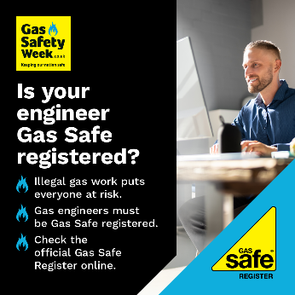 | Anyone carrying out gas work for you must be Gas Safe registered, otherwise they are working illegally and could be putting your life at risk. Always check their Gas Safe ID card before gas work takes place. Find and check qualified engineers at GasSafeRegister.co.uk. #GSW25
Saturday  Don’t DIY Gas | 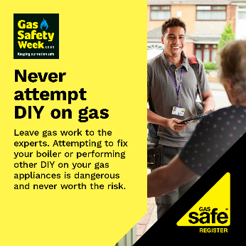 | If you’re facing an issue with a gas appliance, you may think doing it yourself could save money, but it won’t. At best, DIY gas work could end up costing you more. At worst, it could cost a life. Always use a Gas Safe registered engineer. Never DIY gas. Find out more: bit.ly/DoNotDIYGas. #GSW25
Sunday  Spot the warning signs |  | Keep vigilant on the warning signs that your gas appliance is not work properly – and keep your peace of mind by getting them checked by a Gas Safe registered engineer. For more information on gas safety around the home, visit bit.ly/HomeGasSafety. #GSW25

Don’t forget to follow us
During the week, we will be posting gas safety messages. Please retweet and share these important gas safety messages with your followers.
 | @GasSafeRegister www.twitter.com/GasSafeRegister
@GasSafetyWeek
www.twitter.com/GasSafetyWeek

 | www.facebook.com/gassaferegister
 | www.linkedin.com/company/Gas-Safe-Register
 | www.instagram.com/GasSafeRegister
 | www.youtube.com/GasSafeRegister

